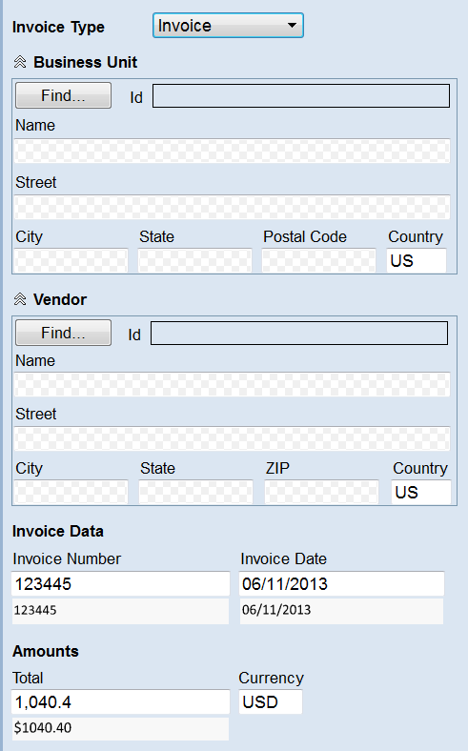This is a blank screen from FlexiCapture For Invoices (FCI) prior to running a test or production batch where the fields are filled in awaiting verification.